Robust Lung Cancer Prediction: Handling Incomplete and Noisy
Clinical Data Using Deep Learning
Final Year Project
PROPOSAL


Supervisor
Rabia Masood
Submitted by
03-134231-005 |  | Abdullah Asim
03-134222-035 |  | Hussnain Khalid

Bachelor in Computer Science
Department of Computer Sciences
Bahria University Lahore Campus
February 2026
Abstract:
Lung cancer stands among Earth's deadliest illnesses. Spotting it sooner beats waiting until later. Medical teams today depend on CT scans to catch growth. Yet scanning each case feels like climbing a mountain. One person faces stacks of pictures per single checkup. Energy fades when workload piles high. Tiny clues vanish under pressure. Few machines today can spot cancer signs, yet most physicians hesitate to rely on them. Since those tools offer no reasoning behind their conclusions, doubt remains. A simple yes or no feels too thin when lives hang in balance. Doctors want to know how the machine reached its view - not just what it decided.
Fixing this issue means giving radiologists a tool to learn on. A desktop app made with Flutter links up to an AI engine coded in Python. Instead of saying yes or no about cancer, it rates each scan layer. Colors do the talking - red marks danger zones, yellow hints at doubt, green says clear. Growth patterns? The system sketches possible paths ahead. Help comes not as answers but as visual clues across slices. What shows up is not certainty, but guidance painted in shades. Next steps become clearer when risks light up piece by piece. Doctors see more than results - they watch probabilities unfold. Doctors move quicker when they know where the machine focuses its attention. Seeing the computer's point of view builds confidence in its suggestions. A clear dashboard meets powerful learning algorithms behind the scenes. Accuracy in patient diagnosis gets a quiet boost from this setup. The tool stays out of the way while helping every step.

Contents
- Introduction: 4
- Problem Description: 5
  - Primary Scope: 5
  - Final Deliverable of the project and Beneficiaries 6
  - Objectives: 7
  - Novelty: 7
- Solution Architecture: 7
  - Key Features: 8
  - Literature Review: 8
- Methodology: 10
- Feasibility Plan: 13
  - Resource Requirement: 13
    - Tools / Technology: 13
    - Budget Estimation: 13
  - Risks Involved: 14
- Market Analysis: 14
- Key Milestones and Schedule: 15
  - Key Milestone 16
  - Gantt Chart:- 17
- References: 18

Introduction:
This chapter provides an overview of the research project and will discuss the background of lung cancer as a leading cause of death due to cancer [1] and the need for early detection and correct diagnosis to improve patient outcomes. Computed tomography (CT scans), specifically low-dose CT scans (LDCT), are used for early detection of lung cancer [2]; however, due to the difficulty in manually interpreting 3D images, radiologists will become fatigued from attempting to interpret the images, thus increasing the risk of error due to fatigue [3]. While there are research studies demonstrating how AI/Deep Learning (DL) can help automate this process, there has not been a successful transition from research to clinical practice [4]. Most current AI Systems for lung cancer diagnosis are essentially black boxes (i.e. Systems that make very accurate predictions); however, the lack of explainability makes clinicians unwilling to utilize the prediction [5]. Most currently developed AI models only analyze lung images from 1 time point, which does not include the critical cross spatio temporal features showing how a tumor has changed and where it will change [6]; thus, these systems do not utilize enough data for accurate prediction. The proposed study will develop an interpretable DL framework designed to bridge these gaps between AI systems and clinical practice; the proposed study will include a slice-level approach for risk analysis of the tumor, provide confidence-aware visual representations for clinicians, and provide predictive modeling for tumor progression; thus, providing clinicians a tool that is accurate, transparent, and trustworthy.

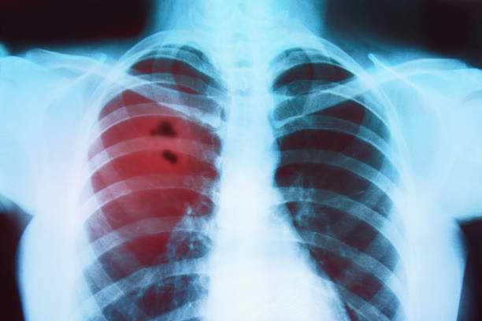

Problem Description:
Spotting problems on CT scans rank among the toughest jobs inside a medical center. Each scan holds hundreds of cross-sectional views, yet spotting a small growth within them feels like tracking down a paperclip in a mountain of leaves [2]. Doctors spend endless stretches focused on screens, plus exhaustion creeps in after too many shifts. Mistakes become more likely once fatigue takes hold [3].
Right now, some AI systems step in to assist, yet here's the catch they stay silent on why they reach certain conclusions [5]. Picture this a machine flags cancer but keeps quiet about where exactly it sees trouble, leaving doctors guessing. On top of that, these tools often freeze time, focusing only on today’s scan without hinting at tomorrow’s risks [6]. Without insight into progression or reasoning, their value drops when used in actual clinics [4]. What if instead, a system could highlight its findings right on the image while also suggesting possible paths ahead? That spark led straight to this effort - building something that spots issues, shows them clearly, then adds a forward-looking layer too.

Primary Scope:
Automatic detection of lung nodules using Deep Learning models. Each image section gets reviewed on its own, then rated for potential danger. What shows up in one frame might hint at trouble later down the line. Green means go; those areas are clear. Where its yellow, hesitation shows up like a pause in thought. Red blocks scream stops, marking danger zones plainly. Boxes of color lay over pictures to guide eyes without words. Heat maps reveal what the model focuses on, pointing straight to specific pixels it finds unusual. Where color intensifies, so does the AI's attention. These visual cues trace patterns across images, guiding eyes toward areas weighed more heavily. Bright spots emerge where suspicion rises, mapping decisions into visible clues. Each shade reflects influence, forming a picture of internal reasoning. A shape appears, hinting where the growth might spread next. This outline gives a glimpse into the tumor's probable path. It shows not what is certain, but where change could happen soon. The image shifts how we see movement within tissue. Instead of guessing, there’s now a marker pointing ahead. What forms in that space may follow this forecast zone. A desktop application made with Flutter that adjusts itself when resized. This tool displays scanning results clearly on screen. Its layout shifts smoothly depending on window size. The program runs locally, showing data without needing extra setup. Built entirely in one framework for consistency across devices. Far from basic, the system runs on Python to manage intense AI tasks behind the scenes. Heavy lifting happens server-side, where logic and computations unfold quietly. This backbone does not show itself but keeps everything moving. Complex work gets done here before anything reaches the surface.

Final Deliverable of the project and Beneficiaries

Final Deliverable:
What comes out at the end? A working Radiologist Decision Support Dashboard. Think desktop app, nothing mobile. Flutter shapes how it looks - sleek, smooth, responsive. Behind that face runs Python with Fast API doing heavy lifting. Inside, U-Net and CNN-RNN models do their job when scans arrive. Upload begins. Processing follows. Then color-marked areas appear and charts showing risk levels. Code goes too - all of it, open and clear. Doctors get a guide written plainly. Engineers see a document detailing training steps, choices made, and why things work.
Beneficiaries:
- Radiologists:
Fatigue sometimes clouds judgment, yet the AI offers another look - lightening tasks while cutting errors. A fresh check steps in when minds grow tired.
- Patients:
Faster diagnosis means they catch things sooner, boosting survival odds right away. Early detection plays a big role here, changing outcomes before problems grow.
- Medical Researchers:
Using our approach called Slice-Level Analysis gives them a way to see tumor shifts through each layer of the lung.
- Hospitals:
Faster reviews happen when AI steps in, letting clinics see more people without waiting. Patients move through quicker since the system cuts down delays behind the scenes.

Objectives:

The goal of this effort is to develop an interpretable, confidence-sensitive deep learning system to improve the responsiveness of lung cancer detection and risk management.

Some specific objectives are as follows:

1. Develop a segmentation-based deep learning model to accurately identify lung nodules within CT scan images and implement a "Slice-Level Risk Trend" analysis to assess the risk of malignancy based on evaluating each slice separately and then aggregating the data across all slices to provide an overall assessment of risk for small lesions.

2. Design a "Confidence Aware" visual display using color code systems (heat maps or confidence layering) to help radiologists understand the confidence level of the model and allow for increased confidence in using the model in clinical practice and incorporate Multi-Level Interpretability; provide both global explanations for classification and local (i.e. pixel level) explanations for diagnostic features.

3. Using spatiotemporal modeling, predict the "Next Likely Development Region" for future development of tumors and create the Clinician Life Sciences Graphical User Interface (CLI GUI) for Radiologists: A desktop application that lets radiologists upload their CT scans, view "Slice Level Risk" via color-coded overlaid images, and compare the outputs generated from the AI-based predictive models with the actual images in an interactive environment.

Novelty:
Something sets this project apart - the move past static detection into interpretable forecasting. While many student efforts stop labeling images as cancer or not, ours goes further by examining each individual scan layer. Instead of a broad verdict, it highlights areas of concern across slices. A new element called Next Likely Development Region brings timing into view. This part suggests where the tumor may grow next. That forward-looking insight rarely appears in typical diagnostic tools.

Solution Architecture:
A system built on client-server design takes care of these problems. On one side runs a powerful artificial intelligence core. The other delivers a simple front-end for people to interact with. Instead of loading everything onto the user's device, processing happens remotely. This split keeps the experience smooth even with basic hardware. Heavy thinking is done behind the scenes. What you see stays fast and clean.

Key Features:
1) Slice-Level Risk Analysis
A fresh look at each slice replaces a single overall mark for the person. Spotting tiny dangers becomes easier when the machine doesn’t just glance at the full picture.
2) Color-Coded Confidence
Sometimes things work like street signals. Safe zones show up as green lights. When yellow appears, the machine hesitates, it is better to have a physician look. A red mark? That spot might be cancerous.
3) Growth Forecasting
A faint outline appears on the display, pointing out where the tumor might spread next. Its form gives clues. The software watches how it bends and stretches. Growth hints hide in those curves. A ghostlike mark shows what comes after.
4) Interactive Dashboard
A fresh workspace layout lets the doctor flip between imaging studies, switch AI highlights as needed, while risk charts stay visible. One glance shows everything without clutter slowing things down.
Literature Review:
Digital health tools started out simple, focused just on paperwork tasks. Now they’re shifting toward smart setups built around patient needs. Back then, early work on online doctor booking showed it could cut wait times plus ease office workload. Research into Saudi Arabia’s "Mawid" platform revealed clearer appointment tracking alongside smoother clinic operations. Still, older systems mostly act like digital phone books - listing physicians without guiding choices when someone does not know which expert fits their issue. That gap pushed developers to explore newer web frameworks. Among them, the MERN stack stands out because MongoDB, Express.js, React.js, and Node.js together handle live medical data better than many alternatives. It turns out Node.js handles input and output without delays, working alongside React.js to keep user screens smooth no matter what the device - this helps dodge issues like overlapping appointments. At the same time, hospitals are testing smart tools powered by artificial intelligence to sort patient needs faster. Some recent work looked at chatbots talking to patients, using systems like Distil BERT to understand what someone says about their health and judge how serious it might be. Still, here's the catch: right now, you can find bots that check symptoms alone or websites that book visits separately - but nothing stitches both together well. The thing being built steps into that space, combining MERN architecture with live conversation smarts so people move straight from describing pain to seeing the correct doctor.

Table 1:Comparative Table
Feature / Methodology | Standard CAD Systems (Traditional) | Deep Learning Models (Standard CNN’s/ResNet) | Our Proposed System (Slice-Level + Forecasting)
Automated Nodule Detection | ✔ | ✔ | ✔
High Accuracy (>90%) | ✘ | ✔ | ✔
Slice-Level Risk Analysis  (Checking every slice individually) | ✘ | ✘ | ✔
Explainability (Heatmaps)  (Showing "Why" it is cancer) | ✘ | ✔ (Limited) | ✔ (Interactive)
Confidence-Awareness  (Red/Yellow/Green Indicators) | ✘ | ✘ | ✔
Future Growth Prediction  (Forecasting the next region) | ✘ | ✘ | ✔
Doctor-Friendly GUI  (Flutter Dashboard) | ✔ (Old Style) | ✘ (Mostly Code) | ✔ (Modern)

Methodology:
This project implements an AI-driven lung cancer prediction system within a Flutter desktop application, utilizing a cloud-integrated deep learning pipeline. Radiologists upload patient CT scans (DICOM/NIfTI) to Firebase Cloud Storage, where a Python FastAPI backend performs HU normalization and resampling. The system employs a Residual U-Net for precise nodule segmentation, followed by a CNN-RNN hybrid model that analyzes the segmented regions to predict the likelihood of lung cancer. This analysis includes color-coded risk stratification—High Risk (Red), Uncertain (Yellow), and Benign (Green)—alongside Spatio-Temporal Forecasting to predict future nodule growth. Metadata and results are synced via Firebase Firestore to an interactive viewer, providing Grad-CAM heatmaps for diagnostic transparency before a final report is generated.Frontend:
Flutter (Dart)
Creating the desktop app along with its image display feature.
Backend:
Python (FastAPI)
(To create the API that connects the App to the AI).
AI/Deep Learning:
PyTorch / TensorFlow
Training these models involves using the U-Net along with the CNN-RNN setup.
OpenCV & SimpleITK
(For processing the medical images).
Database:
Firebase
Saving recent scans is possible alongside patient logs. With each scan, records update automatically. Patient data stays current through ongoing entries. Recent activity gets stored without delay. Logs reflect new information right away.
Integration:
REST API
(Sending images from Flutter to Python and getting JSON results back).

Use Case Diagram For Actors:

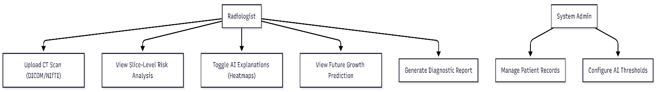

Sequence Diagram for app:

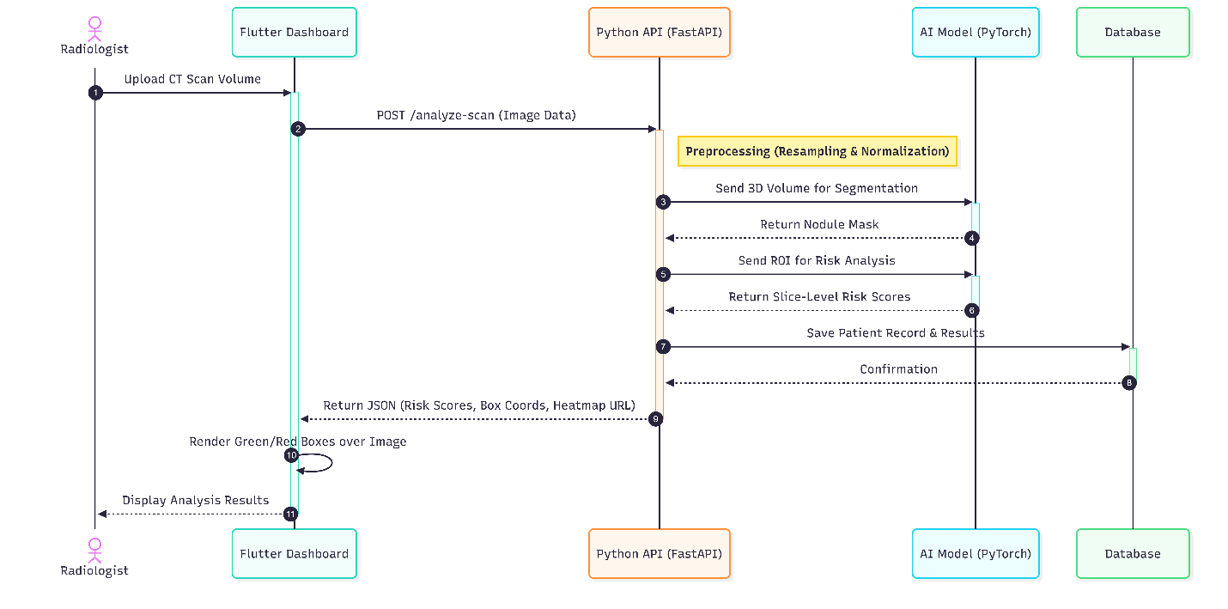

Overall diagram:
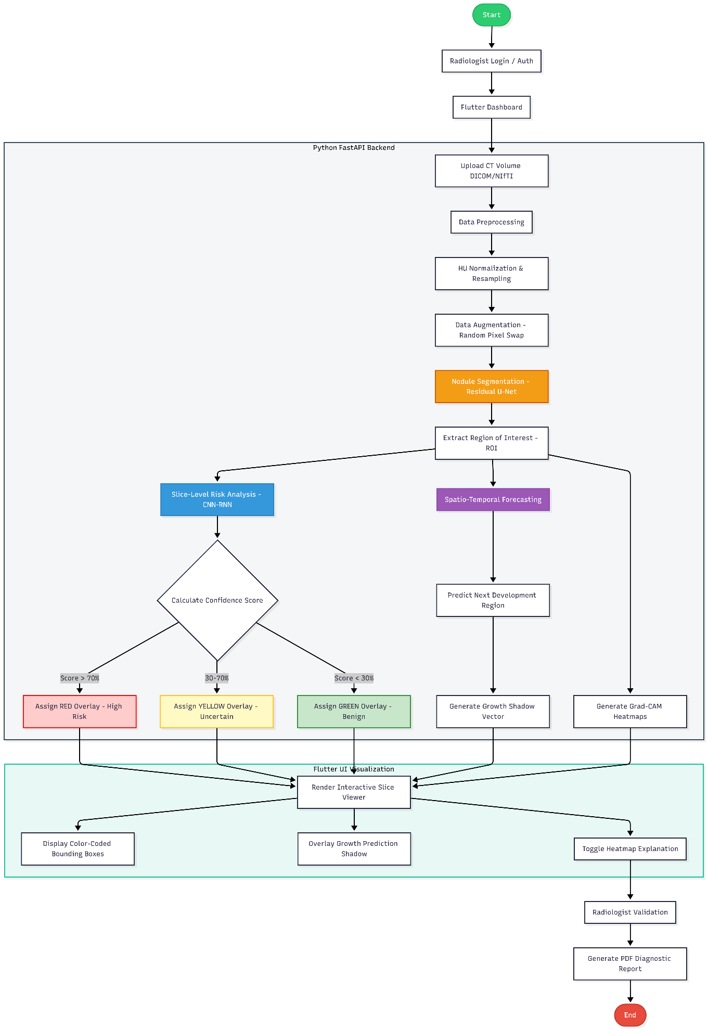

Feasibility Plan:

Resource Requirement:
Team Knows Their Stuff Python skills? Check. Tools such as PyTorch? Used those too. Models built using deep learning methods show how it all fits together piece by piece.
Fine with Flutter when crafting screens. Interface workflows smooth this way. Building apps feel natural here. The toolkit fits well for front-end tasks. Comfort grows each time we shape layouts.
Built APIs before? That kind of work fits right in with what we do - FastAPI or Flask, doesn’t matter. Tying systems together happens through clean backend routes. Simplicity guides how those connections take shape. Tools get picked based on fit, not trends. Each piece links without extra weight slowing it down.

Tools / Technology:
- Hardware Resources:

  - Laptops/PCs: For development, testing, and deployment
- Software & Technologies:

  - Web Development: Mern Technologies (MongoDB , Express , React & Node)
  - AI/NLP Services: Distilbert/Deberta-v3, OpenAI API, or LLAMA3
  - Database: MongoDB / NoSQL
  - Version Control: GitHub (free private repositories)
  - IDEs: Visual Studio Code, jupyterNotebook

Budget Estimation:

- High-Performance Laptop: $1,350 (~PKR 378,000)
- External Storage (1TB SSD): $50 (~PKR 14,000)
- Cloud Training (Colab Pro): $50 (~PKR 14,000)
- Documentation/Misc: $25 (~PKR 7,000)
- Total: $1,475 (~PKR 413,000)

Risks Involved:
Technical Risks from Uneven Data Distribution most of the scans in the collection show healthy tissue instead of cancer. Because of that imbalance, the system could lean toward guessing health too often. To even things out, we’ll generate extra versions of cancer images - twisted slightly in angle, brightness, or shape - to give them more weight without changing their meaning.
Hardware Limitations:
Heavy 3D scan files can slow down the laptop. Because of that, performance may drop during use. To keep things running smoothly, images get handled separately. One after another, they move through the system without overwhelming it.
Integration Issues:
Starting off, linking Flutter using Dart with Python can feel awkward. To fix that confusion, one way is speaking through a shared JSON structure, so both sides catch every message clearly.

Market Analysis:
Few clinics outside wealthy nations can afford today's hospital AI - cost keeps it locked in major medical centers across the West, even as its role widens.
1. Commercial CAD Systems
Few hospital setups today come cheap; most run like sealed units. Our version opens what others keep hidden. Results appear clear, not locked away. Where answers form becomes visible, step by step. Why something happens shows just as much as the outcome itself.
2. Research Projects
Most learners tackle cancer prediction tasks, yet their work often ends inside coding notebooks. Rarely does it evolve into an actual desktop program equipped with a real interface, something this project aims to change.
3. Telemedicine Apps
Finding a doctor? Apps such as Marham or OlaDoc help users pick appointment times. Yet when it comes to reading CT scans, there’s nothing inside them that uses artificial intelligence. What we’re building steps into that space - where tools stop, ours begins.

Comparative Analysis table:
Feature / Platform | OlaDoc | Marham | FindMyDoctorPK | Proposed System
Primary Focus | Doctor Search & Booking | Reviews & Consultations | Home Visits & Telemedicine | AI-Guided Healthcare
AI Chatbot Assistance | ❌ (Manual Search) | ❌ (Manual Selection) | ❌ (Lacks AI Features) | ✔ (Symptom Analysis)
Symptom-to-Specialist Triage | ❌ | ❌ | ❌ | ✔ (Auto-Recommendation)
Doctor Recommendation Engine | ❌ (User decides) | ❌ (Based on reviews) | ❌ | ✔ (Based on Symptoms)
Pharmacy & Lab Integration | Limited | Limited | Limited | ✔ (Centralized)
User Guidance Level | Low (Self-Diagnosis) | Medium (Reviews) | Low (Service-Based) | High (AI-Driven)

Key Milestones and Schedule:
Timeframe | Phase / Activity | Description
Week 1–2 | Planning & Analysis | Requirement analysis & specification, stakeholder consultation, and finalization of scope.
Week 3–4 | Design Phase | System architecture & UI/UX design (wireframes, user flows) and database schema.
Week 5–7 | Backend Development | Backend API development (authentication, doctor/patient CRUD, booking APIs).
Week 6–8 | Frontend Development | Frontend development (main pages, search, booking UI, dashboard).
Week 7–10 | AI Development | AI Chatbot prototype: data collection, model fine-tuning (classification), and conversational flow.
Week 10–12 | Integration | Integration (chatbot with frontend, video API, payment gateway, pharmacy/lab flows).
Week 12–14 | Testing & Optimization | Testing (unit, integration, user acceptance), performance tuning, and security audit.
Week 14–15 | Deployment | Deployment to staging/production, CI/CD setup, and creation of demo materials.
Week 16 | Project Closure | Final report, submission, presentation, and project defence preparation.

Gantt Chart: -
Task / Activity | Month 1-2 | Month 3-4 | Month 5-6
1. Model Design & Architecture  (Selecting algorithms, designing database schema, and planning the API) | ██
2. AI Implementation (Backend)  (Data preprocessing, training U-Net/CNN models in Python) |  | ██
3. Flutter Design (Frontend)  (Designing App screens, UI/UX, and Slice Viewer layout) |  |  | ██

Task / Activity | Month 7-8 | Month 9-10 | Month 11-12
4. System Integration  (Connecting Flutter App with Python Backend via API) | ██
5. Testing & Forecasting Module  (Validating accuracy and adding the "Growth Prediction" feature) |  | ██
6. Final Report & Documentation  (Writing thesis, creating user manuals, and preparing for defence) |  |  | ██

References:

[1] Sung, H., et al. "Global Cancer Statistics 2020: GLOBOCAN Estimates of Incidence and Mortality Worldwide." CA: A Cancer Journal for Clinicians, vol. 71, no. 3, 2021, pp. 209-249.
[2] National Lung Screening Trial Research Team. "Reduced lung-cancer mortality with low-dose computed tomographic screening." New England Journal of Medicine, vol. 365, no. 5, 2011, pp. 395-409.
[3] Waite, S., et al. "Analysis of Perceptual Errors in Radiology." American Journal of Roentgenology, vol. 208, no. 4, 2017, pp. 739-746.
[4] Kelly, C. J., et al. "Key challenges for delivering clinical impact with artificial intelligence." BMC Medicine, vol. 17, no. 1, 2019, p. 195.
[5] Poon, A. I., et al. "Explainable artificial intelligence in radiology: a systematic review." Artificial Intelligence in Medicine, vol. 120, 2021, 102170.
[6] Ardila, D., et al. "End-to-end lung cancer screening with three-dimensional deep learning on low-dose chest computed tomography." Nature Medicine, vol. 25, no. 6, 2019, pp. 954-961.

